Louisiana Oyster Task Force Meeting

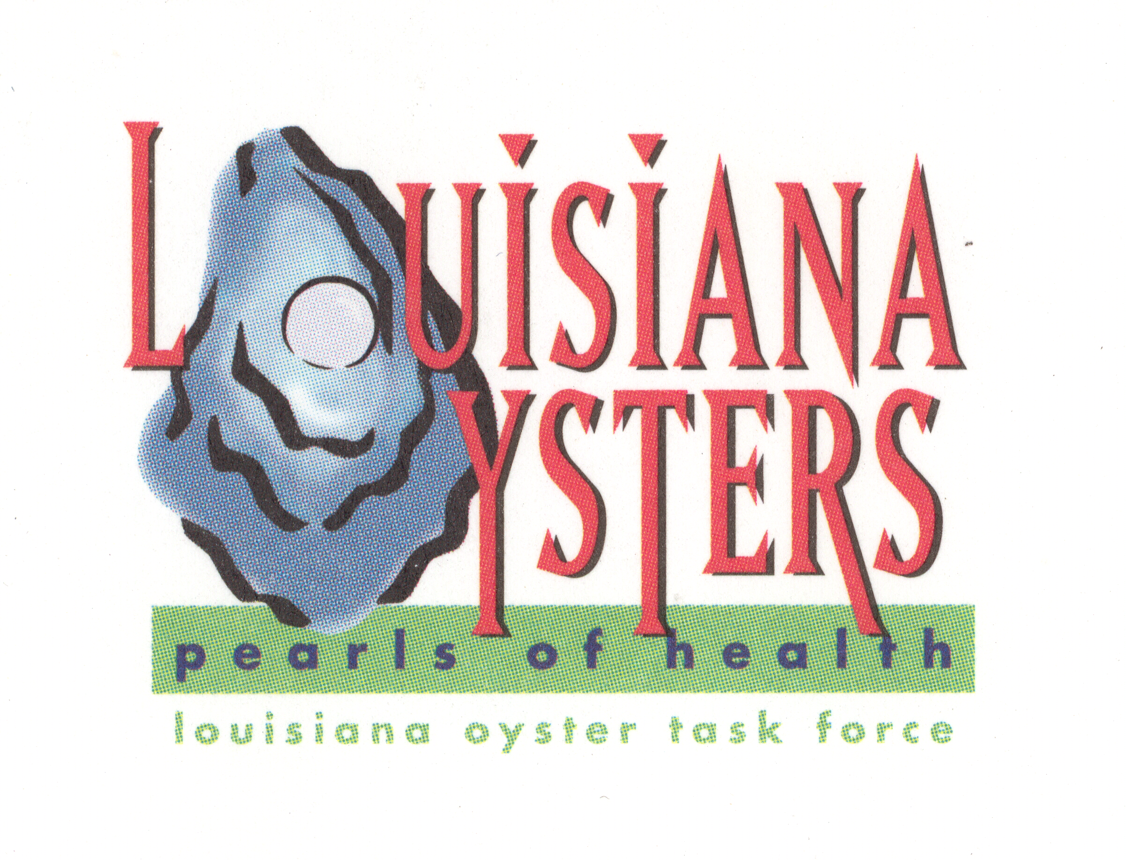
John Tesvich, Chairman

Monday, March 1, 2010
2:30 PM
UNO Advanced Technology Center, 2021 Lakeshore Drive, Suite 210

AGENDA

- Roll Call
- Approval of February 10, 2010 MINUTES
- Old Business
  - Draft Legislation for 2010 Regular Legislative Session – Special Legislative Committee
  - Other
- New Business
  - 2010 Cultch Planting Locations – Patrick Banks
  - Special Opening Hackberry Bay - Peter Vujnovich
  - Other
- Set Next Meeting
- Adjourn

